 | This fact sheet is about:  Enforcement agents recovering money people owe to Councils.
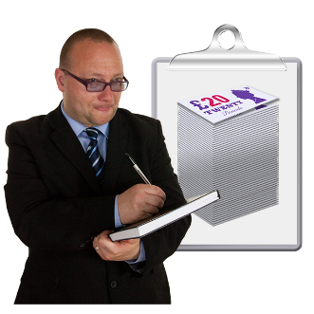 | Recovering money means getting it back.  Enforcement agents recover money when a person has not paid their:
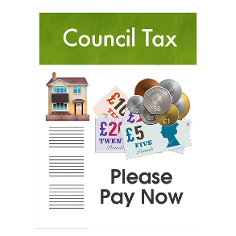 | - Council Tax
 | - Business Rates
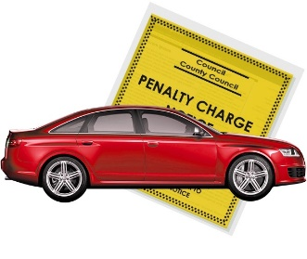 | - Road Traffic Fines
 | What do you do before you contact the Ombudsman?
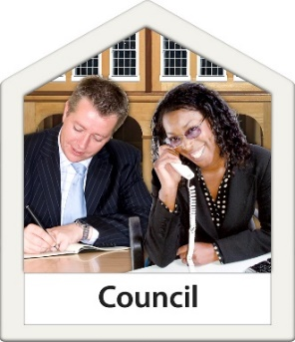 | Complain to your Council
 | What can the Ombudsman do?  We can do something if:
 | - the Council did not tell you what  you owe.
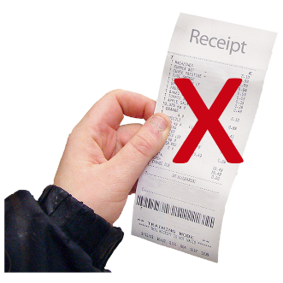 | - the bill the enforcement agent gave you was wrong.
 | - the Council did not say that you would be charged fees.
 | - the enforcement agent did not follow the rules.
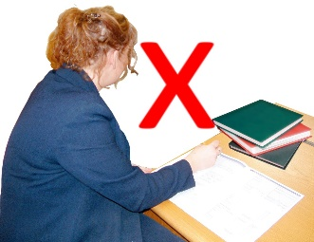 | - the Council does not look at your complaint about an enforcement agent.
 | What can’t the Ombudsman do?  We cannot:
 | - change how much money you  need to pay.
 | - make an enforcement agent take the money bit by bit instead of all in one go.
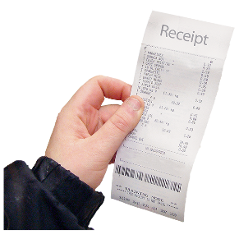 | - get rid of the bill for the enforcement agent’s work.
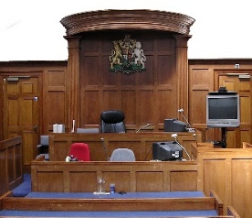 | - look at a complaint that has gone  to a county court.
 | - look at a court order once it has been sent out.
 | Things to think about
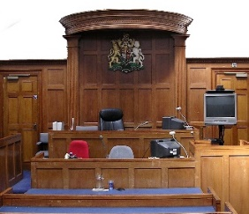 | You may need to take your complaint to County Court.
 | If you do, make sure you take legal advice from a professional.
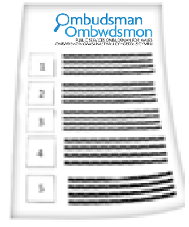 | The Ombudsman can tell the Council what we think it should do if we think it has done something wrong.
 | More Information
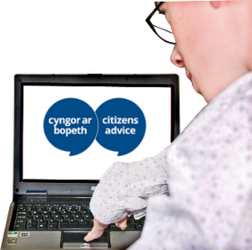 | You can get free advice from Citizens Advice www.citizensadvice.org.uk

 | If you are still not sure if the  Ombudsman can help, contact us.
 | How to contact the Ombudsman
 | 0300 790 0203
 | ask@ombudsman.wales  www.ombudsman.wales
 | @OmbudsmanWales
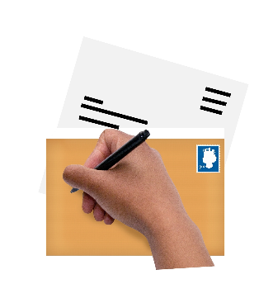 | The Public Services Ombudsman for Wales  1 Ffordd yr Hen Gae  Pencoed  CF35 5LJ
 | This easy read leaflet was prepared by Barod CIC using Photosymbols.

