 | This fact sheet is about: Social Services
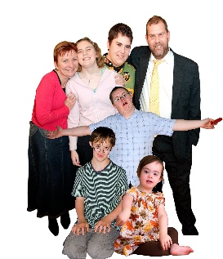 | Social Services give care and support to people with certain needs.
 | People who use social services and their carers can use the Council complaints process if things go wrong.
 | What do you do before you contact the Ombudsman?
 | Complain to the Council.
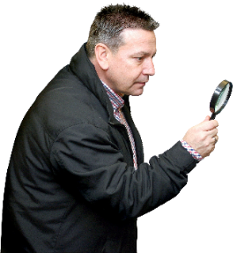 | What can the Ombudsman do?  We can do something to:
 | - look at how they work.
 | - see if they made the right decisions and gave the right care.
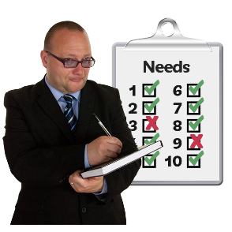 | - see if they did assessments in the  right way.
 | - look at how they dealt with your complaint.

 | What can’t the Ombudsman do?  We cannot:
 | - look at staff issues or say the Council must give you a new social worker.
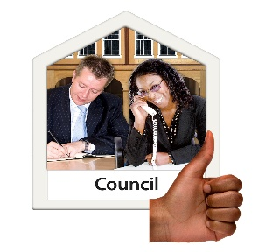 | - ask the Council for information for you.
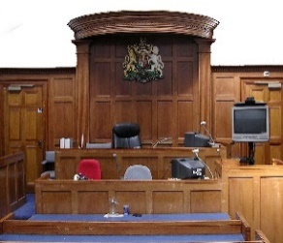 | - get involved if the courts  are involved.
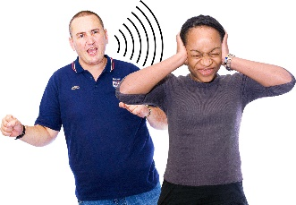 | - look at abuse.
 | - look at an organisation the Council has paid to give care.
 | - look at things more than one organisation decided together.
 | - decide what you need or how it should be paid for.
 | - look at a complaint for a child  unless it is made by their parent  or guardian.
 | - always look at a complaint if you don’t use social services.

 | Things to think about
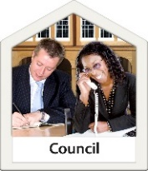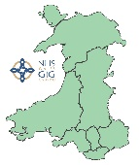 | Councils take charge of keeping people safe but they work with the police and Health Boards.
 | Sometimes a complaint about  keeping people safe needs to go  to them all.
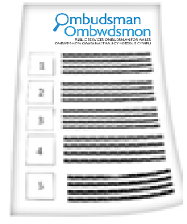 | The Ombudsman can tell the Council what we think it should do if we think it has done something wrong.

 | More information  You can get advice from:
 | Welsh Government at: www.gov.wales/topics/health/socialcare/?lang=en
 | Age Cymru for people over 50:  08000 2223 444 and www.ageuk.org.uk/cymru/
 | Mind Cymru for people with mental health problems: 029 2039 5123 and www.mind.org.uk/about-us/mind-cymru/
 | MENCAP Cymru about learning disability: 029 2074 7588 and www.mencap.org.uk/mencap-cymru
 | The Family Rights Group for families of children needing social care services: 0808 801 0366 and www.frg.org.uk/
 | Care Council for Wales about an individual worker: 0300 30 33 444 and  www.ccwales.org.uk
 | Care and Social Services Inspectorate Wales: 0300 7900 126 and cssiw.org.uk
 | The Older People’s Commissioner for Wales: 029 2044 5030 (for a call back) www.olderpeoplewales.com/en/Home.aspx
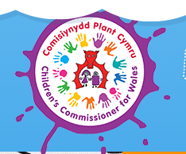 | The Children’s Commissioner for Wales: for under 18s (under 25s if they have been in care) 01792 765600 and www.childcomwales.org.uk/

 | If you are still not sure if the  Ombudsman can help, contact us.
 | How to contact the Ombudsman
 | 0300 790 0203
 | ask@ombudsman.wales  www.ombudsman.wales
 | @OmbudsmanWales
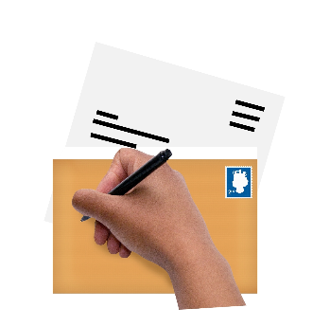 | The Public Services Ombudsman for Wales  1 Ffordd yr Hen Gae  Pencoed  CF35 5LJ
 | This easy read leaflet was prepared by Barod CIC using Photosymbols.

