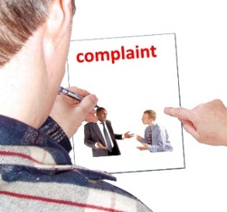 | This fact sheet is about:  School Complaints
 | What do you do before you contact the Ombudsman?
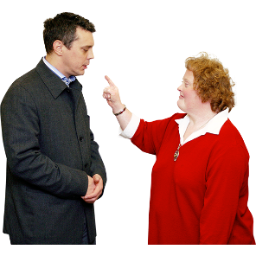 | Complain to the school governing body.  If you are not happy with what the school did with your complaint, complain to  the Council
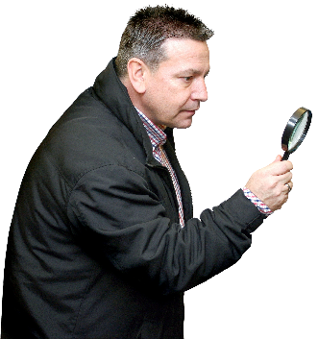 | What can the Ombudsman do? We can look at:
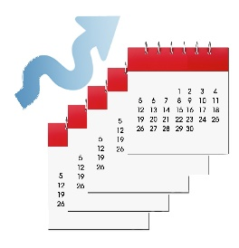 | How the Council has dealt with your complaint about the school.
 | What can’t the Ombudsman do?  We cannot do anything about:
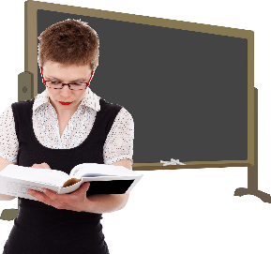 | - what a school teaches.
 | - how a school gets the children  to behave.
 | - how teachers behave.
 | - how a school is run.
 | Things to think about
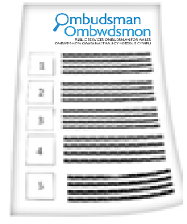 | The Ombudsman can tell the Council or housing association what we think it should do if we think it has done something wrong.
 | More information
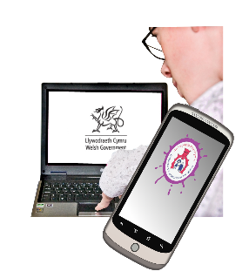 | There is useful information from the Welsh Government at:  http://wales.gov.uk/docs/dcells/publications/121002complaintsschoolsen.pdf

 | If you are still not sure if the  Ombudsman can help, contact us.
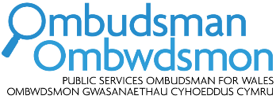 | How to contact the Ombudsman
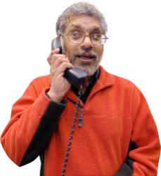 | 0300 790 0203
 | ask@ombudsman.wales  www.ombudsman.wales
 | @OmbudsmanWales
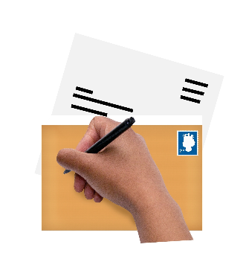 | The Public Services Ombudsman for Wales  1 Ffordd yr Hen Gae  Pencoed  CF35 5LJ
 | This easy read leaflet was prepared by Barod CIC using Photosymbols.

