 | This fact sheet is about:  Record Keeping
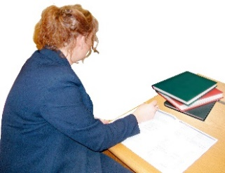 | Record keeping helps show that professionals made decisions in the right way and that services are good
 | What do you do before you contact the Ombudsman?
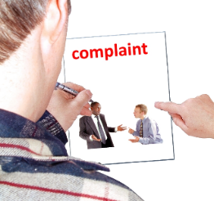 | Complain to the public organisation.
 | If a public organisation will not show you the records or you think something is wrong in the records, you should:
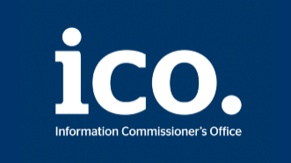 | contact the Information Commissioner’s Office on: 0303 123 1113 or www.ico.org.uk
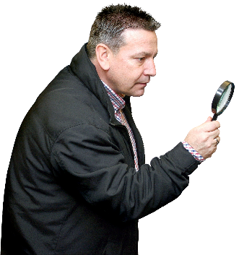 | What can the Ombudsman do?  We can do something if a public organisation:
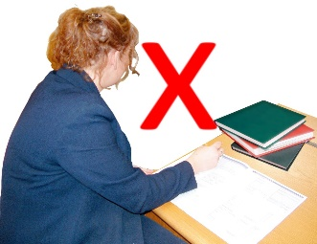 | - has not done a good job keeping records of what it does.
 | - has not kept a record of what it decided to do.
 | - has made something up in the records, instead of telling the truth.
 | - will not show you the records for a person who died.
 | What can’t the Ombudsman do?  We cannot do anything about:
 | - The public organisation not showing you records for someone who is still alive.
 | - The public organisation putting the record right about you, or what happened.

 | Things to think about
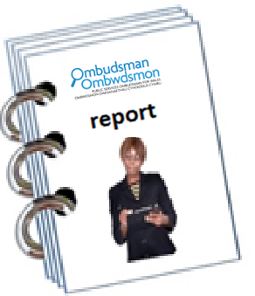 | We may write a report.
 | This will show where the records  are wrong.
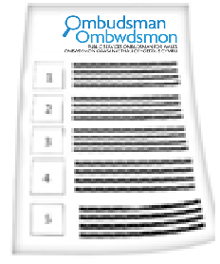 | The Ombudsman can tell the Council or housing association what we think it should do if we think it has done something wrong.

 | If you are still not sure if the  Ombudsman can help, contact us.
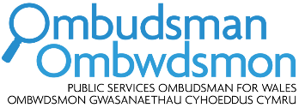 | How to contact the Ombudsman
 | 0300 790 0203
 | ask@ombudsman.wales  www.ombudsman.wales
 | @OmbudsmanWales
 | The Public Services Ombudsman for Wales  1 Ffordd yr Hen Gae  Pencoed  CF35 5LJ
 | This easy read leaflet was prepared by Barod CIC using Photosymbols.

