 | This fact sheet is about: Vulnerable Adults
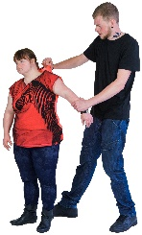 | There are some people who need to be kept extra safe from abuse and neglect.
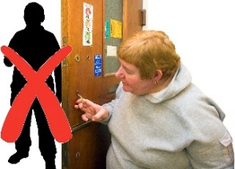 | They are called Vulnerable Adults.
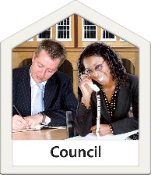 | Keeping Vulnerable Adults safe is called  Safeguarding. The Council must do this.
 | What do you do before you contact the Ombudsman?
 | Complain to the Council.
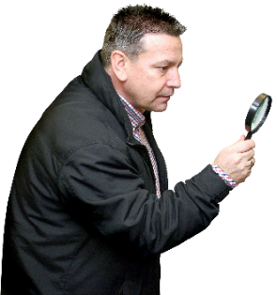 | What can the Ombudsman do?  We can look at a complaint if:
 | - a Vulnerable Adult has not been treated fairly by Social Services.
 | - Social Services did not follow the rules when it was told a Vulnerable Adult was in danger.
 | - Social Services did not deal with a complaint properly.

 | What can’t the Ombudsman do?  We cannot look at:
 | - complaints about abuse
 | - Social Services staff issues
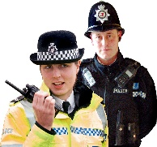 | - complaints about the Police

 | Things to think about
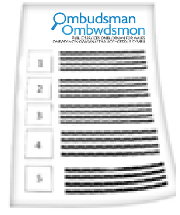 | The Ombudsman can tell the Council what we think it should do if we think it did something wrong.
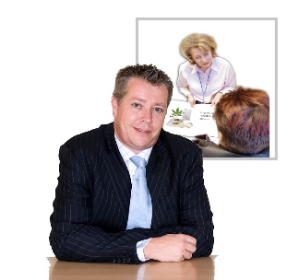 | We can also look at things  Heath Services did.
 | If you want to complain about the Police not keeping someone safe you must tell the Police Commissioner.
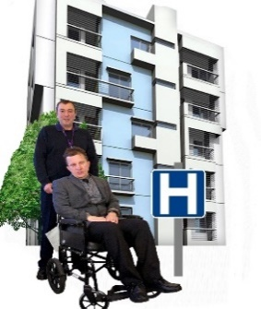 | Health Boards can look at what happened if there is abuse in the NHS.
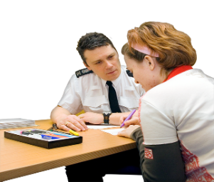 | Police look at where laws are broken.
 | The Disclosure and Barring Service (DBS) checks that someone is safe to work with vulnerable people.
 | The Ombudsman will only share information to keep people safe.
 | More information
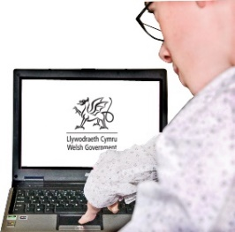 | Welsh Government have information at: www.cymru.gov.uk/topics/health/socialcare/safeguarding/?lang=en
 | Age Cymru give advice on: 08000 223 444 or at www.ageuk.org.uk/cymru/
 | Mind Cymru helps people with mental health problems on: 0300 123 3393 or at: www.mind.org.uk/aboutus/our-work-in-wales/
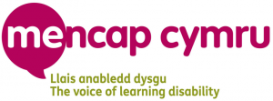 | MENCAP Cymru gives support to do with learning disabilities on: 0808 808 1111 or at: www.mencap.org.uk/wales

 | If you are still not sure if the  Ombudsman can help, contact us.
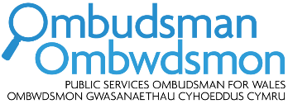 | How to contact the Ombudsman
 | 0300 790 0203
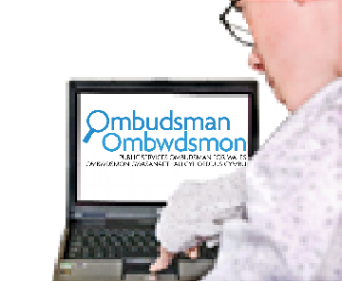 | ask@ombudsman.wales  www.ombudsman.wales
 | @OmbudsmanWales
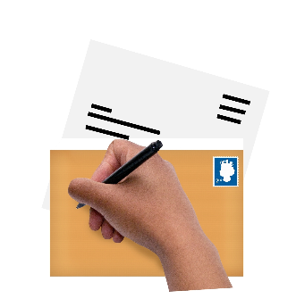 | The Public Services Ombudsman for Wales  1 Ffordd yr Hen Gae  Pencoed  CF35 5LJ
 | This easy read leaflet was prepared by Barod CIC using Photosymbols.

