 | This fact sheet is about: Planning Enforcement
 | There are rules about what you can build.  The Council makes sure you follow them.
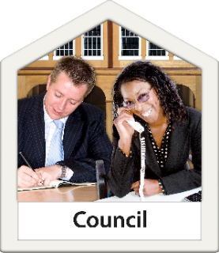 | The Council decides what can and cannot be built.
 | But if a plan is for building in a National Park, the National Park Authority decides.

 | What do you do before you contact the Ombudsman?
 | Complain to your Council
 | What can the Ombudsman do?  We can:
 | - see if the Council followed the rules.
 | - look at delays.
 | - ask the Council why it decided  what it did.
 | What can’t the Ombudsman do?  We cannot:
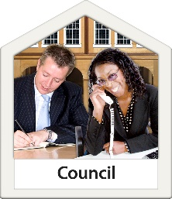 | - make a Council do something.
 | - look at a complaint if you were allowed to appeal.
 | Things to think about
 | Lots of things don’t need Planning Permission.
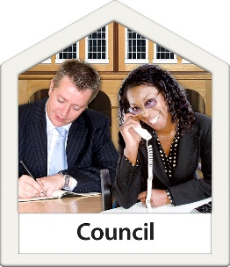 | Councils do not have to do anything if they think they do not need to.
 | Sometimes people build things without the Planning Permission they need.
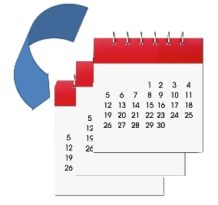 | Councils should let them ask for back dated Planning Permission.
 | Councils should have a policy you can see about Planning.
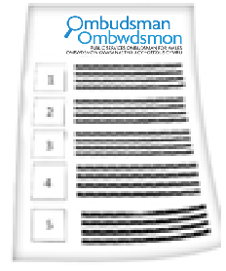 | The Ombudsman can tell the Council what we think it should do if we think it has done something wrong.

 | More information
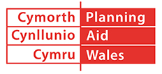 | Planning Aid Wales can help on:  029 2062 5000 or at www.planningaidwales.org.uk
 | You can find more information at:  www.planningportal.gov.uk/wales/public
 | Your Council website may also be helpful.

 | If you are still not sure if the  Ombudsman can help, contact us.
 | How to contact the Ombudsman
 | 0300 790 0203
 | ask@ombudsman-wales.org.uk  www.ombudsman-wales.org.uk
 | @OmbudsmanWales
 | The Public Services Ombudsman for Wales  1 Ffordd yr Hen Gae  Pencoed  CF35 5LJ
 | This easy read leaflet was prepared by Barod CIC using Photosymbols.

