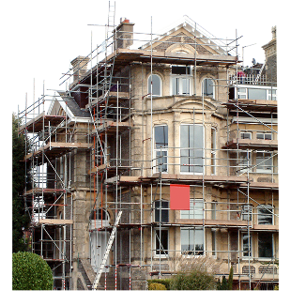 | This fact sheet is about: Planning Applications
 | A Planning Application is the way you must ask if you can build something.
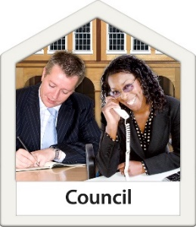 | The Council normally deals with  Planning Applications.
 | It decides what people can build.
 | The Council must follow the rules.
 | What do you do before you contact the Ombudsman?
 | Complain to your Council
 | What can the Ombudsman do?  We can look at whether:
 | The Council did not follow the rules.
 | The Council must:
 | - tell you that someone wants to build something that might affect you.
 | - tell everyone who should  have a say.
 | - ask you about plans they changed.
 | - say why it said yes to a plan.
 | - think about your worries about  the plan.

 | We can look at complaints about your own application like if the Council:
 | - gave you bad planning advice.
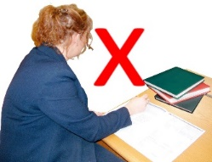 | - did not record their advice.
 | - did not follow the rules.

 | What can’t the Ombudsman do?  We cannot look at a complaint if:
 | - the Council followed the rules.
 | - there is a right to appeal.
 | - the Council have not decided yet.
 | - it is about a private argument.

 | More information
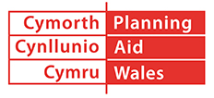 | Planning Aid Wales gives information on 029 2062 5000 or at: www.planningaidwales.org.uk
 | You can find more information found at: www.planningportal.gov.uk/wales/public
 | The Council’s website may also be helpful.
 | Things to think about
 | The Ombudsman can tell the Council what we think it should do if we think it has done something wrong.
 | If you are still not sure if the  Ombudsman can help, contact us.
 | How to contact the Ombudsman
 | 0300 790 0203
 | ask@ombudsman.wales  www.ombudsman.wales
 | @OmbudsmanWales
 | The Public Services Ombudsman for Wales  1 Ffordd yr Hen Gae  Pencoed  CF35 5LJ
 | This easy read leaflet was prepared by Barod CIC using Photosymbols.

