 | This fact sheet is about:  Noise Nuisance
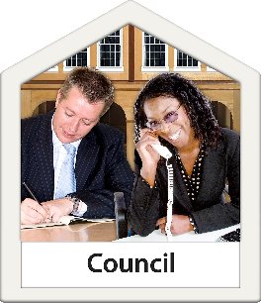 | The Council must look at problems you have with noise coming from a house  or business.
 | What do you do before you contact the Ombudsman?
 | Complain to your Council.
 | You can tell the Council or Housing Association if the noise is being made by their tenants.
 | The Council needs to follow the rules when it looks at complaints.
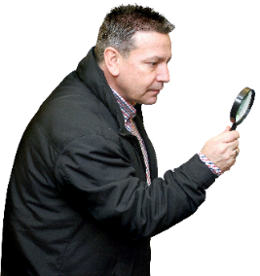 | What can the Ombudsman do?  We can look to see:
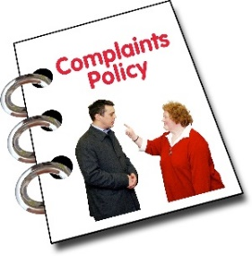 | - how the Council deals with  noise complaints.
 | - if it looked at your complaint.
 | - if it did something wrong when it looked at your complaint.
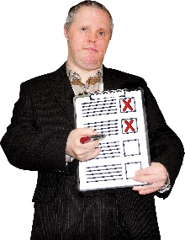 | - if it did not do what was needed to put things right.
 | - if it did not tell you what it decided.
 | - if it only looked at some of the information or the wrong information.
 | What can’t the Ombudsman do?  We cannot:
 | - look at the noise nuisance itself.  That is the Council’s job.
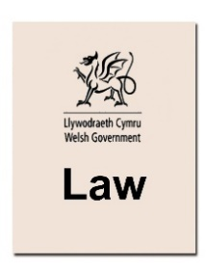 | - say that the noise is illegal.
 | - tell the Council it made a  wrong decision.
 | Things to think about
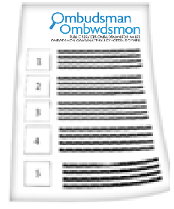 | The Ombudsman can tell the Council what we think it should do if we think it has done something wrong.
 | More information
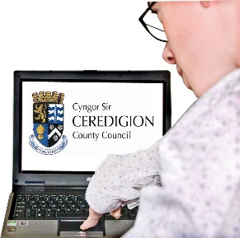 | The Council may have information about noise complaints on its website.

 | If you are still not sure if the  Ombudsman can help, contact us.
 | How to contact the Ombudsman
 | 0300 790 0203
 | ask@ombudsman.wales  www.ombudsman.wales
 | @OmbudsmanWales
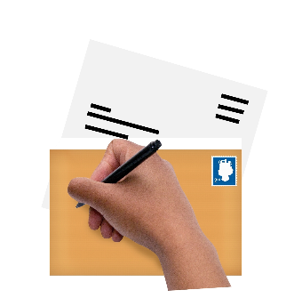 | The Public Services Ombudsman for Wales  1 Ffordd yr Hen Gae  Pencoed  CF35 5LJ
 | This easy read leaflet was prepared by Barod CIC using Photosymbols.

