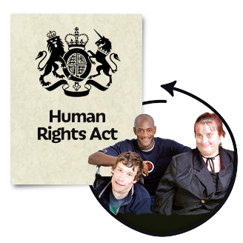 | This fact sheet is about:  The Human Rights Act
   | Human Rights are things like:  - safety  - dignity  - freedom  - respect for private and family life.
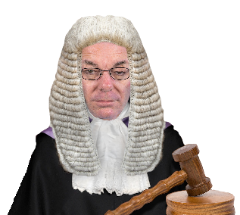 | The Human Rights Act is the law that says you must be allowed these things.
 | What to do before you contact the Ombudsman?
 | Complain to the Government or Council Service that did not consider your rights.
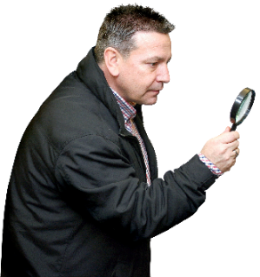 | What can the Ombudsman do?  The Ombudsman can
 | The Ombudsman looks at complaints if:
 | - a Government or Council service  is unfair
 | - or makes your life harder
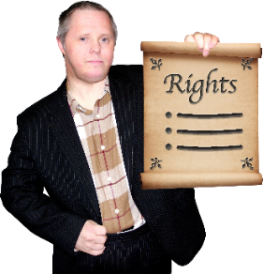 | - decide if the Council or Government service did not consider your rights.
 | - ask them to think again  about what they did.
 | What can’t the Ombudsman do?  We cannot:
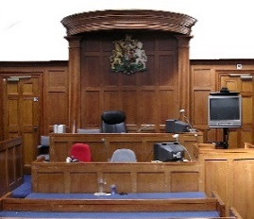 | Say that the law has been broken.  A court must decide this.
 | Things to think about
 | The Ombudsman can say what we think the Council or Government service should do if we think it did something wrong.
 | You do not need a solicitor or advocate to go to the Ombudsman.  The Ombudsman service is free.
 | More information  You can get advice from:
 | The Equality and Human Rights Commission (EHRC)  Telephone 0800 800 0082
 | The EHRC works with the Equality Advisory Support Service (EASS).  Telephone 0800 800 0082  www.equalityadvisoryservice.com
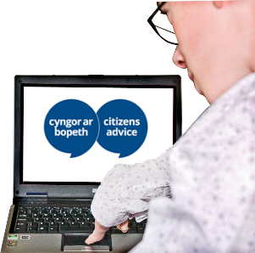 | Citizens Advice Wales:  Telephone 08444 77 20 20  www.citizensadvice.org.uk/wales

 | If you are still not sure if the  Ombudsman can help, contact us.
 | How to contact the Ombudsman
 | 0300 790 0203
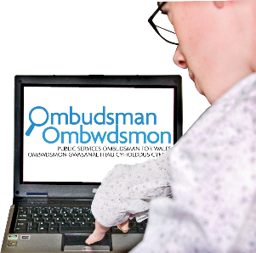 | ask@ombudsman.wales.  www.ombudsman.wales
 | @OmbudsmanWales
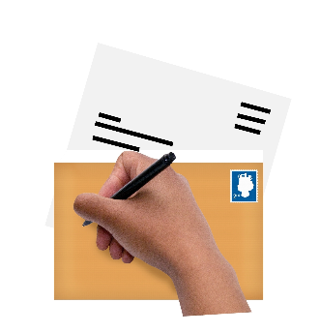 | The Public Services Ombudsman for Wales  1 Ffordd yr Hen Gae  Pencoed  CF35 5LJ
 | This easy read leaflet was prepared by Barod CIC using Photosymbols.

