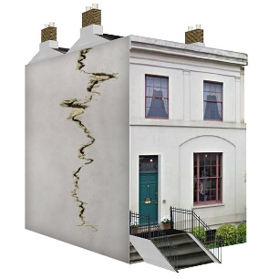 | This fact sheet is about: Housing Repairs
 | The Ombudsman can only look at complaints about Councils and  Housing Associations
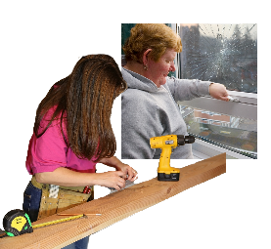 | The Councils and Housing Associations must do repairs on their houses.
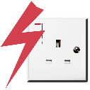 | The house can have gas and electrical things in it. Your landlord must make sure  they are safe.
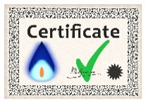 | You should be given a certificate to say they are safe.
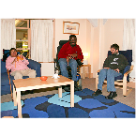 | If you are a tenant there are things you must take care of.
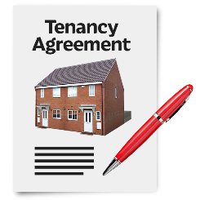 | Your tenancy agreement will say what you must do.
 | What do you do before you contact the Ombudsman?
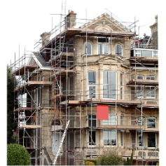 | Tell the Council or Housing Association if your house needs work. Give them time to do the repairs.
 | Complain to your Council or  Housing Association

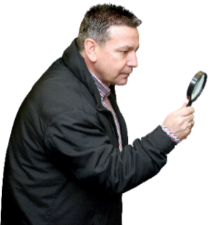 | What can the Ombudsman do?  We can look at complaints where the landlord has not:
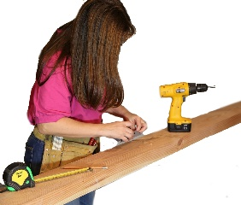 | - done repairs.
 | - done the repairs in good time.
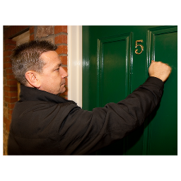 | - come to do repairs when they  said they would.
 | What can’t the Ombudsman do?  We cannot do anything about:
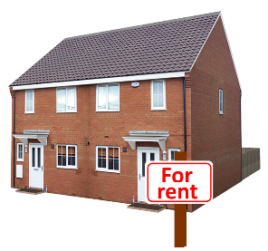 | - complaints about private landlords.
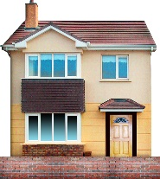 | - making the Council or Housing Association improve your home if it does not need it.
 | Things to think about
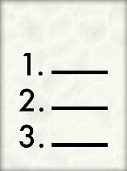 | Your tenancy agreement may say other things the Council or Housing  Association will do.
 | Your Council or Housing Association may give you a Tenants Handbook  for information.
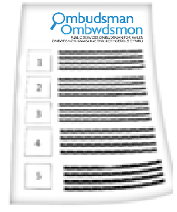 | The Ombudsman can tell the Council or Housing Association what we think it should do if we think it did something wrong.
 | More information
 | Shelter Cymru gives free housing advice and support: 0845 075 5005  www.sheltercymru.org.uk
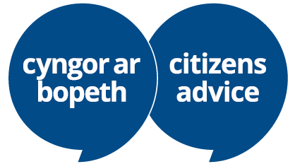 | Citizens Advice Cymru  gives free advice and support  www.citizensadvice.org.uk/wales/
 | Your local Assembly Member  may also be able to help.

 | If you are still not sure if the  Ombudsman can help, contact us.
 | How to contact the Ombudsman
 | 0300 790 0203
 | ask@ombudsman.wales  www.ombudsman.wales
 | @OmbudsmanWales
 | The Public Services Ombudsman for Wales  1 Ffordd yr Hen Gae  Pencoed  CF35 5LJ
 | This easy read leaflet was prepared by Barod CIC using Photosymbols.

