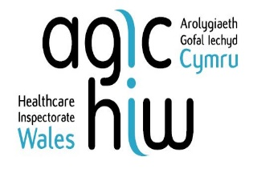 | This fact sheet is about:  Healthcare Inspectorate Wales (HIW)
 | HIW makes sure Welsh health care is safe and good quality.
 | HIW looks at health services and says how well they are doing.
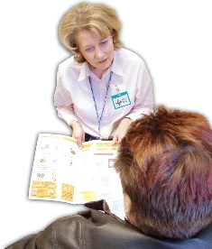 | And that people kept in hospital for their mental health can get a second opinion from a doctor.
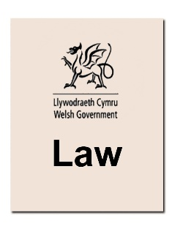 | It makes sure the law is followed.
 | What do you do before you contact the Ombudsman?
 | If you think HIW has broken the rules the Ombudsman may look at your complaint.
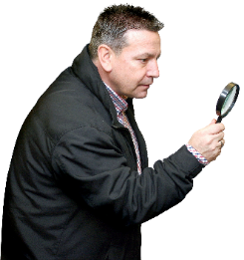 | What can the Ombudsman do?  We can look at:
 | - how health services are inspected.
 | - how HIW report on health services.
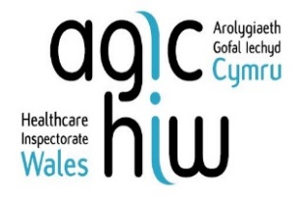 | - how HIW do their job.
 | - if HIW have not answered  your complaint.
 | What can’t the Ombudsman do?  We cannot look at:
 | - HIW staff.
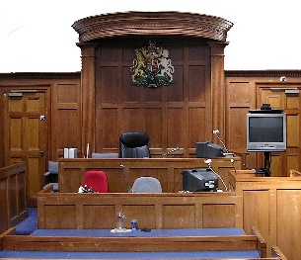 | - anything HIW has done that involves the courts.
 | - something HIW decided if they followed the rules.

 | Things to think about
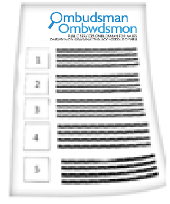 | The Ombudsman can tell HIW what we think it should do if we think it did something wrong.
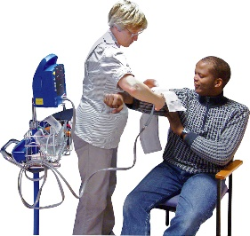 | HIW do not look at complaints about health treatments themselves.
 | The NHS deal with this kind of complaint.
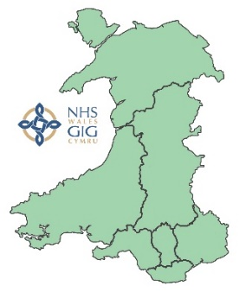 | HIW may do something about a problem with the way the NHS works.
 | You need to make a complaint if you are unhappy with something to do with:
 | - your HIW registration.
 | - what HIW did to make changes  to a service.
 | More information
 | There is more on HIW and their complaints procedure at:  www.hiw.org.uk

 | If you are still not sure if the  Ombudsman can help, contact us.
 | How to contact the Ombudsman
 | 0300 790 0203
 | ask@ombudsman.wales  www.ombudsman.wales
 | @OmbudsmanWales
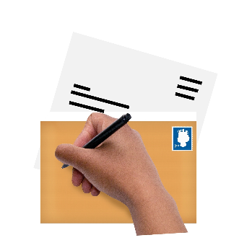 | The Public Services Ombudsman for Wales  1 Ffordd yr Hen Gae  Pencoed  CF35 5LJ
 | This easy read leaflet was prepared by Barod CIC using Photosymbols.

