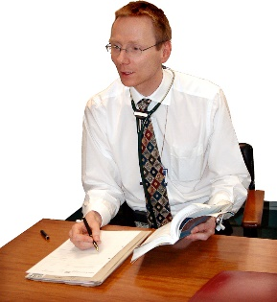 | This fact sheet is about:  General Practitioners (GPs)
 | The Ombudsman can look at complaints about NHS treatment but not  private healthcare.
 | What do you do before you contact the Ombudsman?
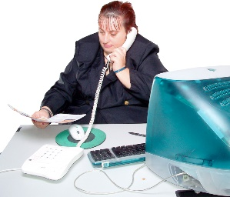 | You should complain to the practice if your complaint is about a GP or someone who works there.

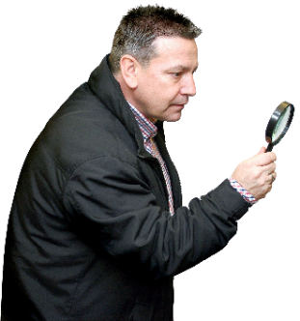 | What can the Ombudsman do?  We can look at:
 | - complaints about the quality of  your care.
 | - when GP services do not work how  they should.
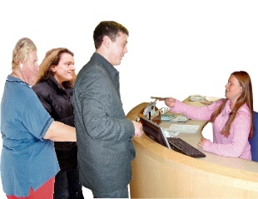 | - poor service from a GP surgery.
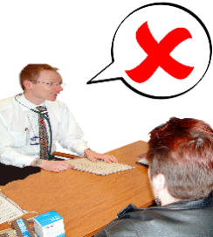 | - when you have been taken off  the GP list.
 | - complaints about out of  hours services.
 | What can’t the Ombudsman do?  We cannot:
 | - stop your GP working.
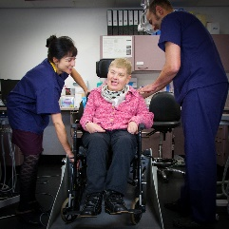 | - get involved in your treatment.
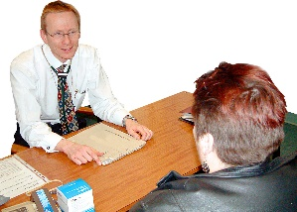 | - get you back on the GP list.
 | Things to think about
 | The Ombudsman will look at if the care was good enough when you  were treated.
 | But he will not expect it to be perfect.
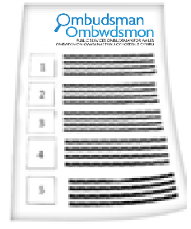 | The Ombudsman can tell the GP practice what we think it should do if we think it has done something wrong.
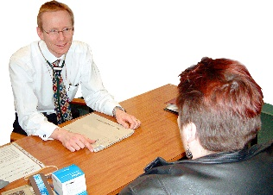 | GPs can take you off their list if:
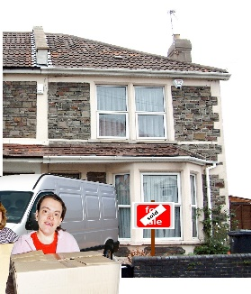 | - you move away.
 | - you do not get along.
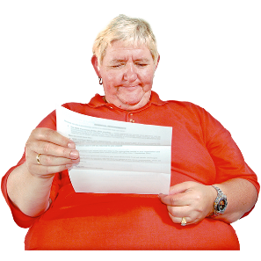 | You should get a letter to say this might happen and why.
 | You should not be taken off a GP list for making a complaint.
 | More information
 | The Community Health Council (CHC) helps with complaints.  Their helpline is on: 0845 6447814
 | Your local Health Board may also help. www.wales.nhs.uk/ourservices/directory

 | If you are still not sure if the  Ombudsman can help, contact us.
 | How to contact the Ombudsman
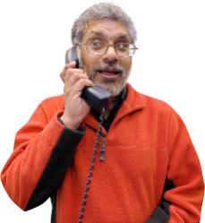 | 0300 790 0203
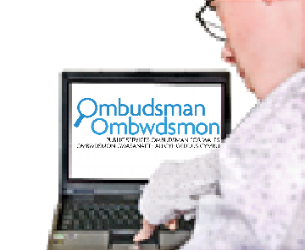 | ask@ombudsman.wales  www.ombudsman.wales
 | @OmbudsmanWales
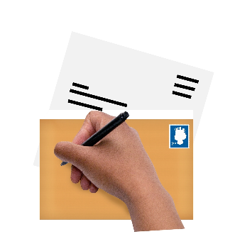 | The Public Services Ombudsman for Wales  1 Ffordd yr Hen Gae  Pencoed  CF35 5LJ
 | This easy read leaflet was prepared by Barod CIC using Photosymbols.

