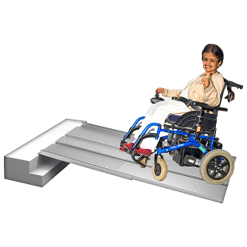 | This fact sheet is about:  The Disabled Facilities Grant
 | The Disabled Facilities Grant is:
 | - run by the Council.
 | - for people on a low income and without many savings.
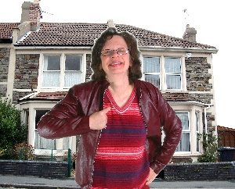 | - for people who live at home independently.
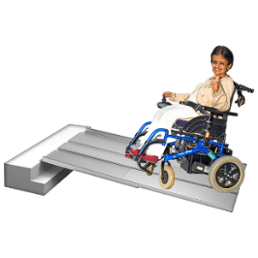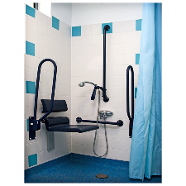 | The Grant can be for:  - ramps or stairlifts  - walk in showers  - new kitchens  - heating and lighting
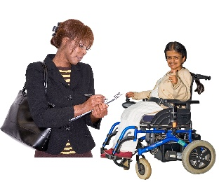 | An Occupational Therapist will visit you when you ask for a Grant.
 | They will help the Council decide how important the work is.
 | What do you do before you contact the Ombudsman?
 | If you live in a Council or Housing Association house, ask them about making your home accessible.
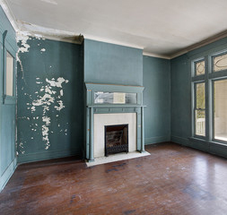 | If they cannot do this they can suggest you move to a more accessible home.
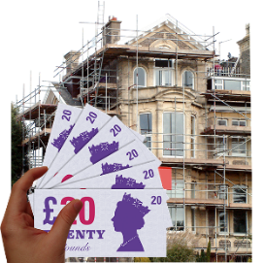 | The Council may also offer you a loan if the work costs more than the grant.
 | What can the Ombudsman do?  We can see if the Council:
 | - took too long to send an Occupational Therapist out to you.
 | - took too long to decide.
 | - looked at all the information before saying no.
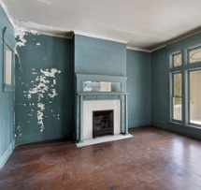 | - checked the builders work.
 | What can’t the Ombudsman do?  We cannot do anything about:
 | - the builder working on your house.
 | - making the Council give you money.
 | Things to think about
 | The Ombudsman can tell the Council or Housing Association what we think it should do if we think it has done  something wrong.

 | If you are still not sure if the  Ombudsman can help, contact us.
 | How to contact the Ombudsman
 | 0300 790 0203
 | ask@ombudsman.wales  www.ombudsman.wales
 | @OmbudsmanWales
 | The Public Services Ombudsman for Wales  1 Ffordd yr Hen Gae  Pencoed  CF35 5LJ
 | This easy read leaflet was prepared by Barod CIC using Photosymbols.

