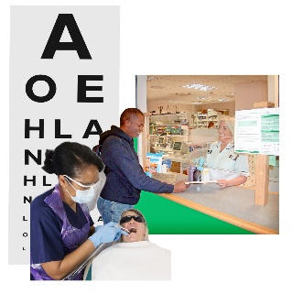 | This fact sheet is about:  Dentists, Opticians and Pharmacists
 | Community health providers like dentists, opticians and pharmacists are:
 | - Independent.
 | - Paid for by the health board.
 | They can be one person or a  big company.
 | What do you do before you contact the Ombudsman?
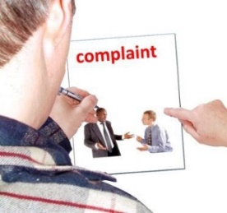 | You must complain to the body first.  Your local Community Health Council (CHC) can help you.
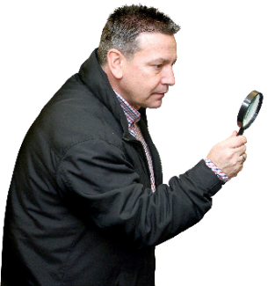 | What can the Ombudsman do?  We can do something if:
 | - the care is paid for by the NHS and the care was not good for you, or your child.
 | - you have been told you cannot have NHS Dental care but you have not been told why.
 | What can’t the Ombudsman do?  We cannot:
 | - do anything about care you pay  for yourself.
 | - tell a Dentist or Optician they  must see you.
 | More information
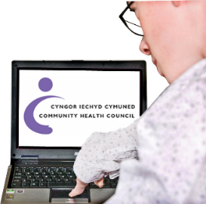 | Your local Community Health Council (CHC) can help make your complaint.  Phone 0845 6447814 or 02920 235558
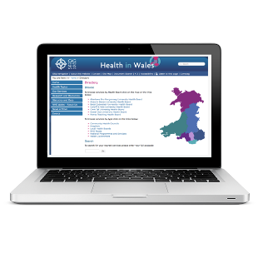 | Your Local Health Board may also help. You can find your Health Board at www.wales.nhs.uk/ourservices/directory
 | If you are still not sure if the  Ombudsman can help, contact us.
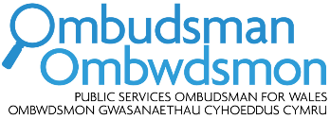 | How to contact the Ombudsman
 | 0300 790 0203
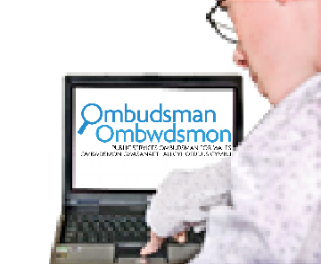 | ask@ombudsman.wales  www.ombudsman.wales
 | @OmbudsmanWales
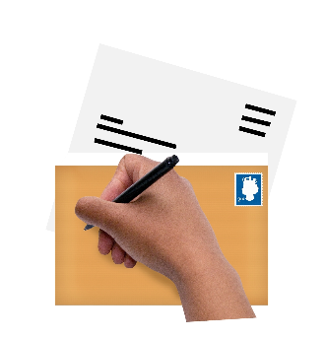 | The Public Services Ombudsman for Wales  1 Ffordd yr Hen Gae  Pencoed  CF35 5LJ
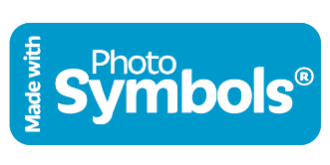 | This easy read leaflet was prepared by Barod CIC using Photosymbols.

