 | This fact sheet is about:  Continuing NHS Health Care
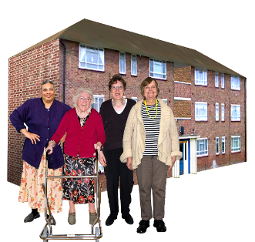 | If you live in a care home or get care at home, the Health Board might have to pay for your care.
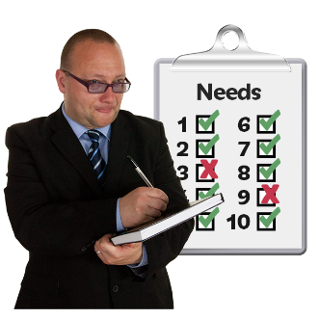 | First the Health Board will decide if your health care needs are your main needs.  They will see if your health care support is more important for you than other support.
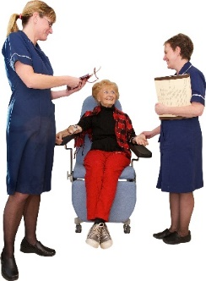 | They will do this by making an assessment.
 | There are a lot of people asking about their care. You might have to wait for the Health Board to decide.
 | What do you do before you contact the Ombudsman?
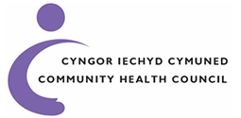 | Contact your local Community Health Council (CHC).  They can help you make a complaint.
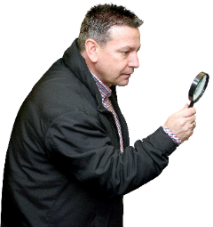 | What can the Ombudsman do?  We can do something if the NHS:
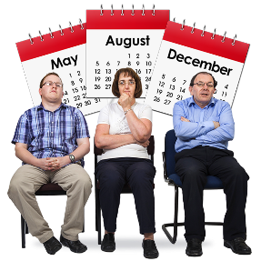 | - are taking over a year to say if they will pay for your health care.
 | - did not do a good job looking at why you asked for continuing health care.
 | - did not tell you why you cannot have continuing health care.
 | What can’t the Ombudsman do?  We cannot:
 | - assess your health care needs.
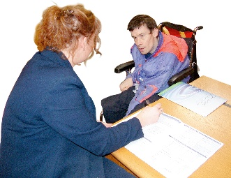 | - help you make a claim for continuing care funding.
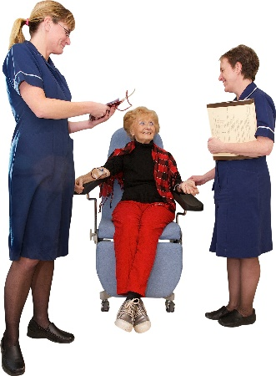 | - tell you if you should have continuing care funding.
 | - decide if the Health Board assess people correctly.
 | Things to think about
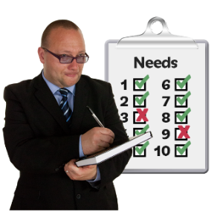 | If your complaint is right the Ombudsman might ask the Health Board to look at your needs again.
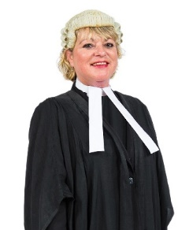 | You do not need a solicitor to help you complain to the Ombudsman.
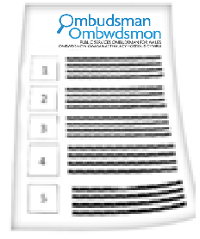 | The Ombudsman can tell the Health Board what we think it should do if we think it has done something wrong.

 | More Information  You can find out more about continuing health care funding here:
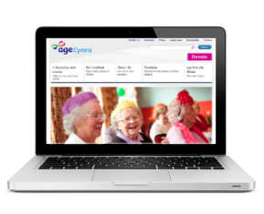 | Age Cymru: 0800 169 65 65 www.agecymru.org.uk
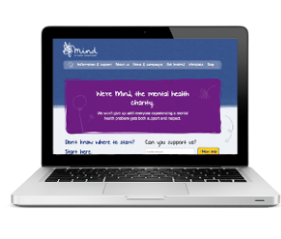 | MIND on mental health: 02920 395123 www.mind.org.uk
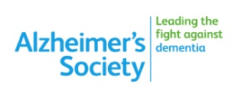 | The Alzheimer’s Society:  02920 480593 South Wales or:  01248 671137 North Wales  www.alzheimers.org.uk
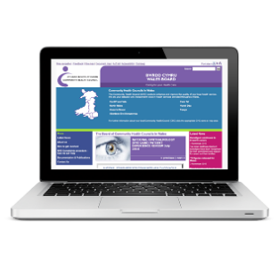 | Community Health Councils (CHCs):  0845 6447814 www.patienthelp.wales.nhs.uk
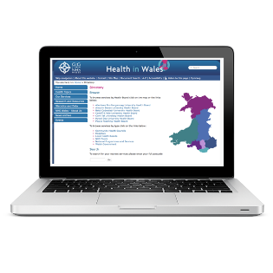 | Your Local Health Board www.wales.nhs.uk/directory.cfm
 | Claiming continuing NHS healthcare: http://www.cciss.org.uk/home
 | If you are still not sure if the  Ombudsman can help, contact us.
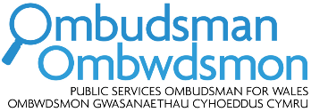 | How to contact the Ombudsman
 | 0300 790 0203
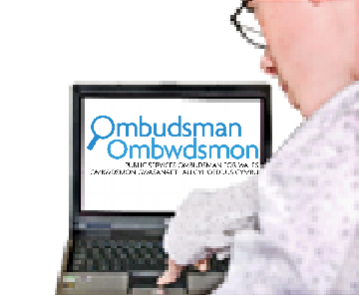 | ask@ombudsman.wales  www.ombudsman.wales
 | @OmbudsmanWales
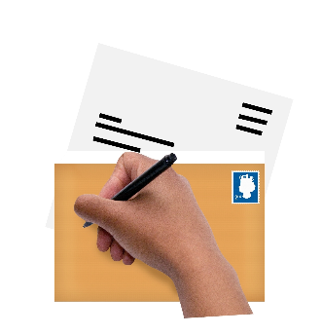 | The Public Services Ombudsman for Wales  1 Ffordd yr Hen Gae  Pencoed  CF35 5LJ
 | This easy read leaflet was prepared by Barod CIC using Photosymbols.

