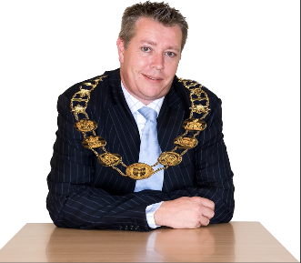 |  |  | This fact sheet is about:  Community and Town Councils
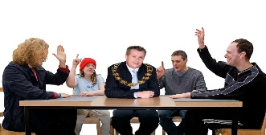 |  |  | There are 735 Community and Town Councils in Wales. The Councils:
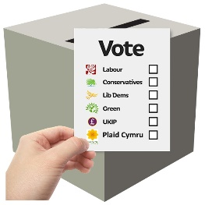 |  |  | - are elected by local people.
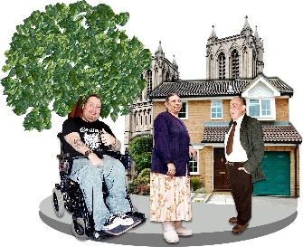 |  |  | - deliver services that make their community better.
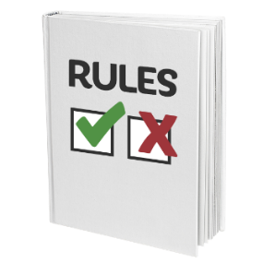 |  |  | - have rules they must follow.  You can ask the Clerk of the  Council for the rules.
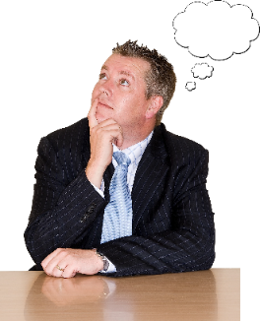 |  |  | What do you do before you contact the Ombudsman?
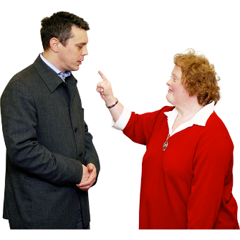 |  |  | Complain to your Community or Town Council.
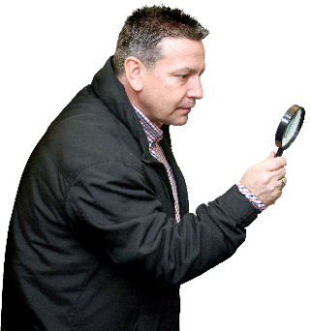 |  |  | What can the Ombudsman do?  We can do something if:
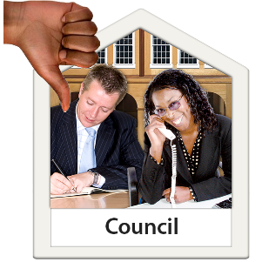 |  |  | - the Community or Town Council has not followed the rules.
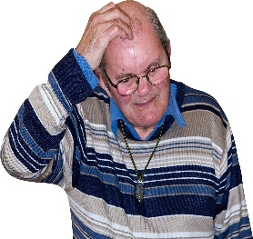 |  |  | - you have suffered because the Community or Town Council did  not follow the rules.
 |  |  | - you and other people have suffered because the Community or Town Council did not follow the rules.
 |  |  | What can’t the Ombudsman do?  We cannot:
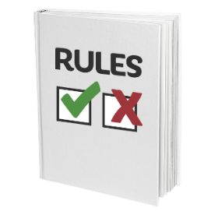 |  |  | - change a decision if the Council  has followed the rules.
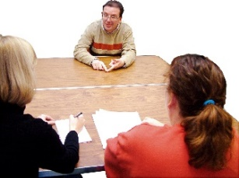 |  |  | - look at a complaint if there is a way  to appeal about a decision.
 |  | 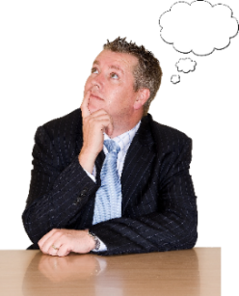 |  |  | Things to think about
 |  |  |  |  | If your complaint is about one person on the Council you should read the Code of Conduct – General Information factsheet about how to complain.
 |  | 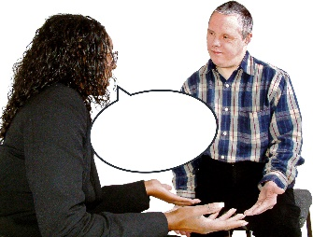 |  |  | You should first talk to the Clerk to a council about your complaint.
 |  | 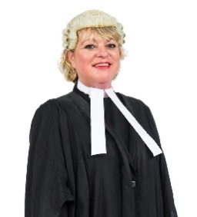 |  |  | You do not need a solicitor to help you complain.
 |  | 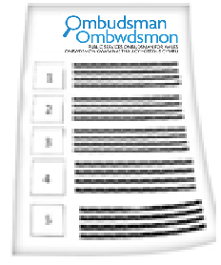 |  |  | The Ombudsman can tell the Council or housing association what we think it should do if we think it has done something wrong.
 |  |  |  | More information
 | 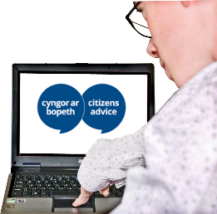 |  |  | You can get free advice and support  from Citizen Advice:  www.citizenadvice.org.uk
 | 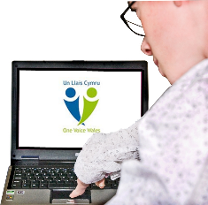 |  |  | There is more about Community Councils  at One Voice Wales:  www.onevoicewales.org.uk

 | If you are still not sure if the  Ombudsman can help, contact us.
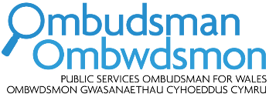 | How to contact the Ombudsman
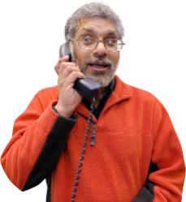 | 0300 790 0203
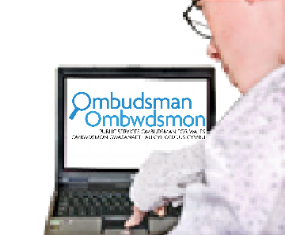 | ask@ombudsman.wales  www.ombudsman.wales
 | @OmbudsmanWales
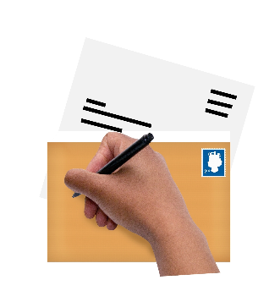 | The Public Services Ombudsman for Wales  1 Ffordd yr Hen Gae  Pencoed  CF35 5LJ
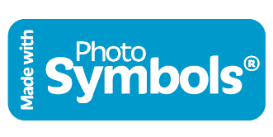 | This easy read leaflet was prepared by Barod CIC using Photosymbols.

