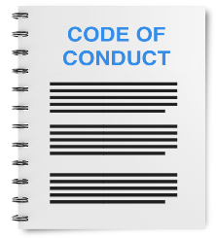 | This fact sheet is about:  Codes of Conduct
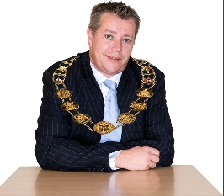 | It is about elected members of:  - Local Authorities.  - Community Councils.
 | - Fire and Rescue Authorities.
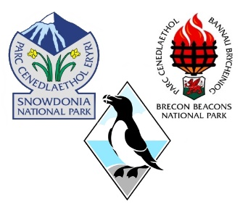 | - National Park Authorities.
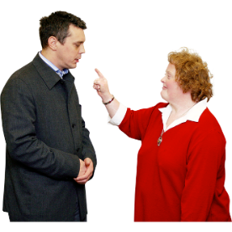 | It is about how members behave.
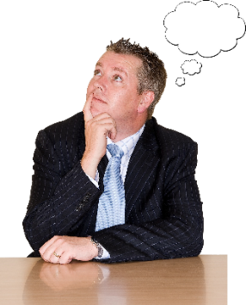 | What do you do before you contact the Ombudsman?
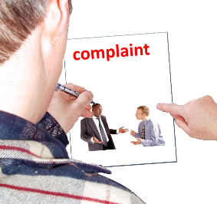 | You can complain directly to  the Ombudsman.
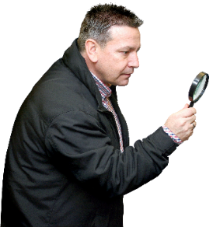 | What can the Ombudsman do?  We can do something if:
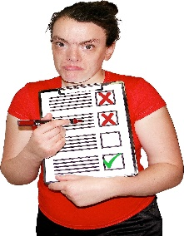 | - you tell us what you think the elected member did wrong.
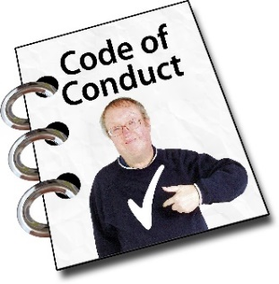 | - we think they are not following their Code of Conduct.
 | What can’t the Ombudsman do?  We cannot:
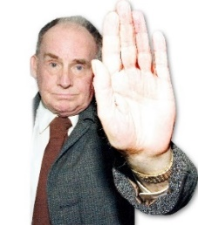 | - stop someone being a member.  - ask or make a member leave.
 | - ask or make a member pay money to say sorry.
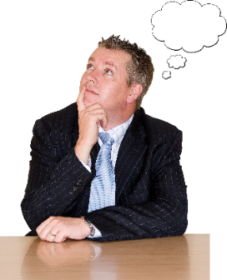 | Things to think about
 | When you make a complaint, you need to show what they have done wrong.
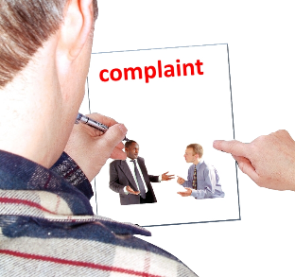 | You need to use the complaints form.  You can find the form on our website.  www.ombudsman.wales
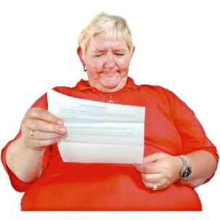 | If you make a complaint, everything will be shared with the member you are complaining about. This includes your name. This information may  become public.
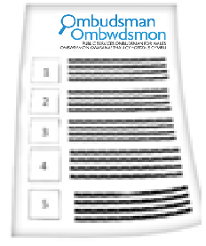 | If the Ombudsman thinks the member has not followed the Code, we can tell the Council or a special Tribunal.
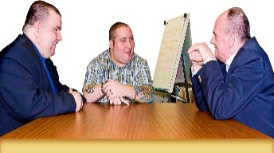 | They will decide how to put things right
 | More information
You can read our Fact Sheet.
This tells you what we do when we get a complaint about a local authority member’s conduct.
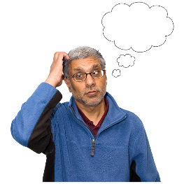 | If you are still not sure if the  Ombudsman can help, contact us.
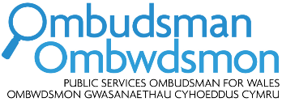 | How to contact the Ombudsman
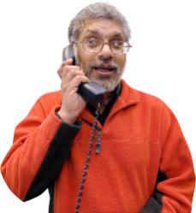 | 0300 790 0203
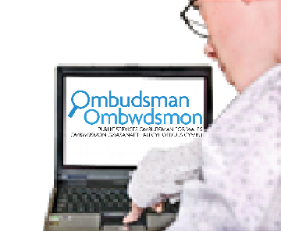 | ask@ombudsman.wales  www.ombudsman.wales
 | @OmbudsmanWales
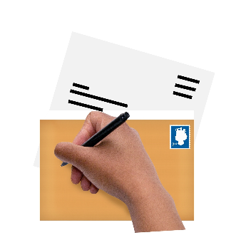 | The Public Services Ombudsman for Wales  1 Ffordd yr Hen Gae  Pencoed  CF35 5LJ
 | This easy read leaflet was prepared by Barod CIC using Photosymbols.

