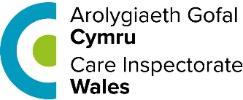 | This fact sheet is about:  Care Inspectorate Wales (CIW)
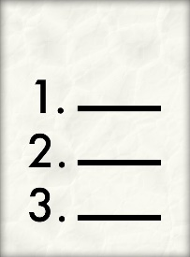 | CSSIW make sure social care services are run properly. It does this by:
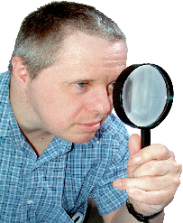 | - Inspections
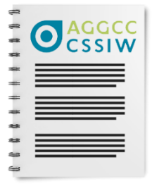 | - Regulations
 | - Reviewing
 | What do you do before you contact the Ombudsman?
 | Complain to CSSIW first.
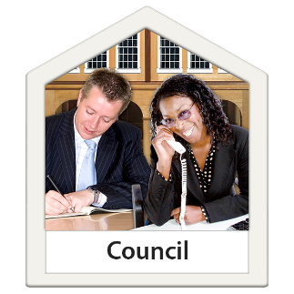 | Complaints about Social Services should be made to the Council.

 | What can the Ombudsman do?  We can do something if CSSIW:
 | - has not made other organisations follow the rules.
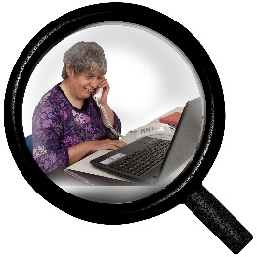 | - has not looked at the Council’s social services properly.
 | has not come back to you about your complaint.
 | - is not telling us about things properly.

 | What can’t the Ombudsman do?  We cannot do anything about:
 | - complaints about CSSIW staff.
 | - a properly made CSSIW decision.

 | Things to think about
 | The Council may get involved if they have paid for the service.
 | - We will look at complaints from people who pay for their own care.
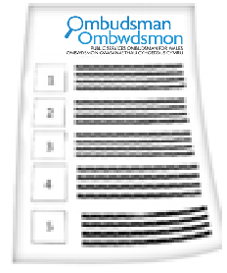 | The Ombudsman can tell CSSIW what we think it should do if we think it has done something wrong.

 | More information
 | More about CSSIW can be found here: cst@justice.gov.uk
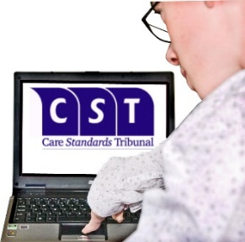 | If you think CSSIW made the wrong decision about standards being used you can go to the Care Standards Tribunal:  Phone 01325 289350  Email: cst@justice.gov.uk

 | If you are still not sure if the  Ombudsman can help, contact us.
 | How to contact the Ombudsman
 | 0300 790 0203
 | ask@ombudsman.wales  www.ombudsman.wales
 | @OmbudsmanWales
 | The Public Services Ombudsman for Wales  1 Ffordd yr Hen Gae  Pencoed  CF35 5LJ
 | This easy read leaflet was prepared by Barod CIC using Photosymbols.

