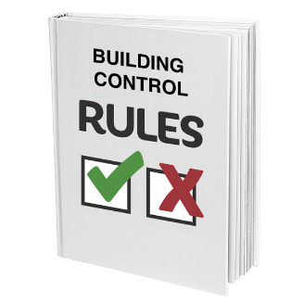 | This fact sheet is about:  Building Control
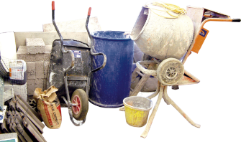 | This is about a Council’s role in Building Regulation applications and  Building Controls.
 | What do you do before you contact the Ombudsman?
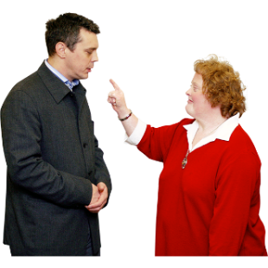 | Complain to the Council
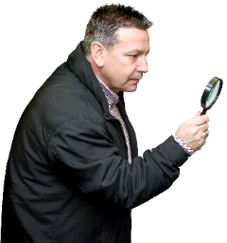 | What can the Ombudsman do?
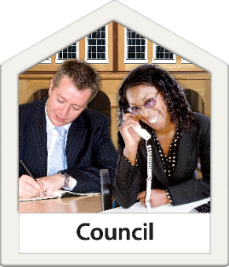 | We can do something if the Council:
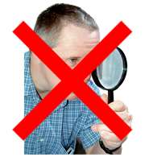 | - has not looked at plans and the building work to make sure it  follows the rules.
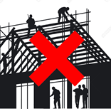 | - said the building work follows the rules but it does not really follow  the rules.
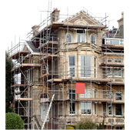 | - does not take any action and your house is badly affected.
 | What can’t the Ombudsman do?  We cannot:
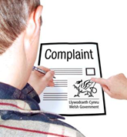 | - change the Council’s decision to say no to a building application.  You need to complain to the  Welsh Government about this.
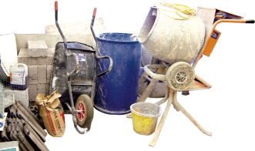 | - stop building work next door if the Council said the work follows the rules. You might need legal advice.
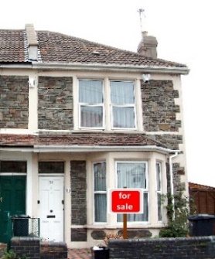 | - change anything that was already wrong with your house before you bought it.
 | Things to think about
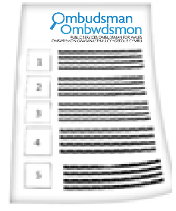 | The Ombudsman can tell the Council what we think it should do if we think it  has done something wrong.
 | More information
 | You can find more information about Building Regulations at: www.planningportal.gov.uk
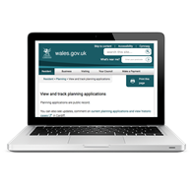 | Your Council website should have more information.

 | If you are still not sure if the  Ombudsman can help, contact us.
 | How to contact the Ombudsman
 | 0300 790 0203
 | ask@ombudsman.wales  www.ombudsman.wales
 | @OmbudsmanWales
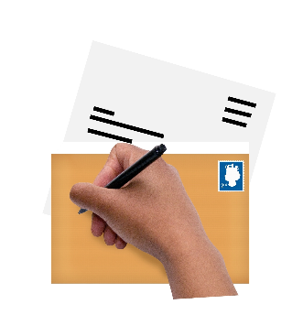 | The Public Services Ombudsman for Wales  1 Ffordd yr Hen Gae  Pencoed  CF35 5LJ
 | This easy read leaflet was prepared by Barod CIC using Photosymbols.

