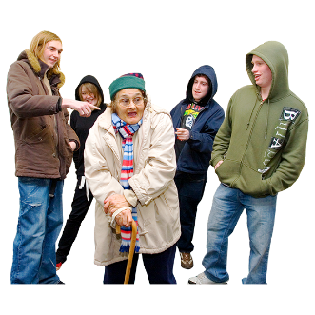 | This fact sheet is about:  Antisocial Behaviour
 | Antisocial behaviour includes:
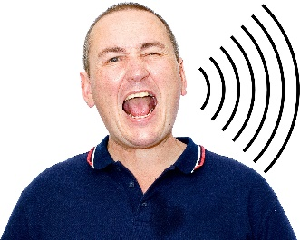 | - people making too much noise.
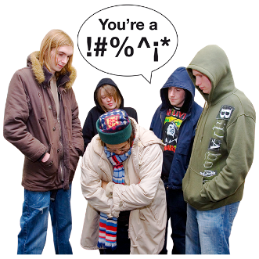 | - being rude.
 | - saying they will hurt someone.
 | - breaking or damaging someone’s things.
 | What do you do before you contact the Ombudsman?
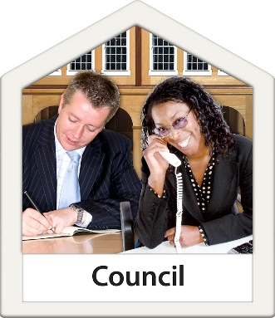 | Complain to your Council.
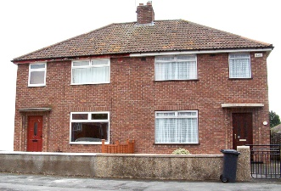 | If your home is owned by a Council or Housing Association, tell it.
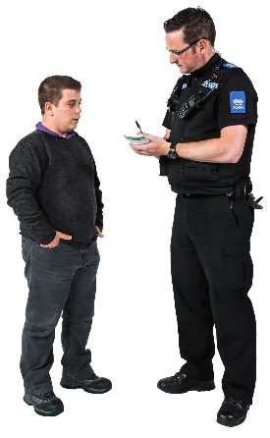 | Some behaviour may be a crime.  You should tell the police.
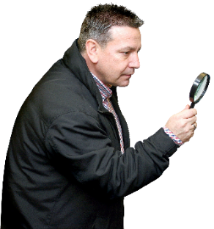 | What can the Ombudsman do?
 | We can do something if the Council or Housing Association:
 | - does not have rules to follow when it is told about antisocial behaviour.
 | - does not tell you the rules it will follow.
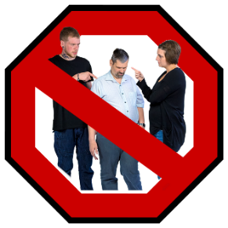 | - does not look at all the ways it can help stop the antisocial behaviour.
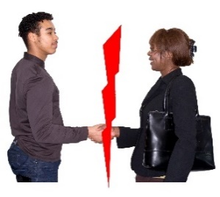 | - does not work with others including the police if needed.
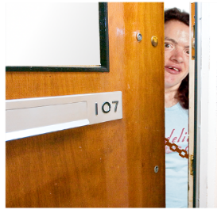 | - does not tell you how to keep safe.
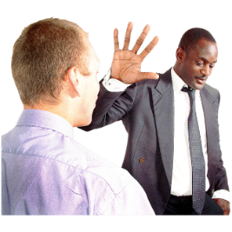 | - does not tell you what they are doing to stop the antisocial behaviour.
 | - takes too long to stop the antisocial behaviour.
 | What can’t the Ombudsman do?  We cannot do anything about:
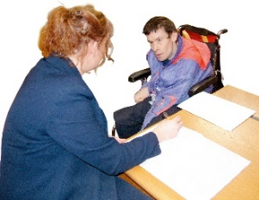 | - your complaint until you have told the Council or Housing Association.
 | - the Council or Housing Association if the antisocial behaviour stopped over 12 months ago.
 | Things to think about
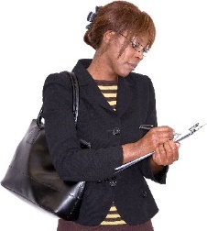 | You should keep a note of:
 | - when the antisocial behaviour started and what is happening.
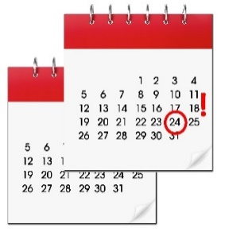 | - when you told the Council or Housing Association.
 | - anything that you told the Council or Housing Association.
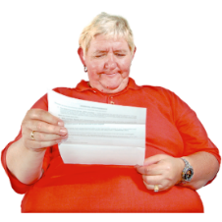 | - anything the Council or Housing Association told you.
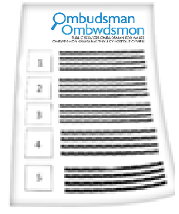 | The Ombudsman can tell the Council or Housing Association what we think it should do if we think it has done something wrong.
 | If you are still not sure if the  Ombudsman can help, contact us.
 | How to contact the Ombudsman
 | 0300 790 0203
 | ask@ombudsman.wales  www.ombudsman.wales
 | @OmbudsmanWales
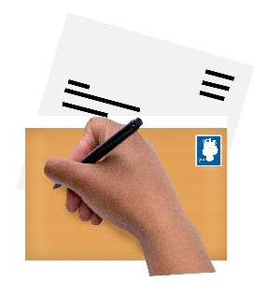 | The Public Services Ombudsman for Wales  1 Ffordd yr Hen Gae  Pencoed  CF35 5LJ
 | This easy read leaflet was prepared by Barod CIC using Photosymbols.

